Devcon3 | 2017 conference **overview**

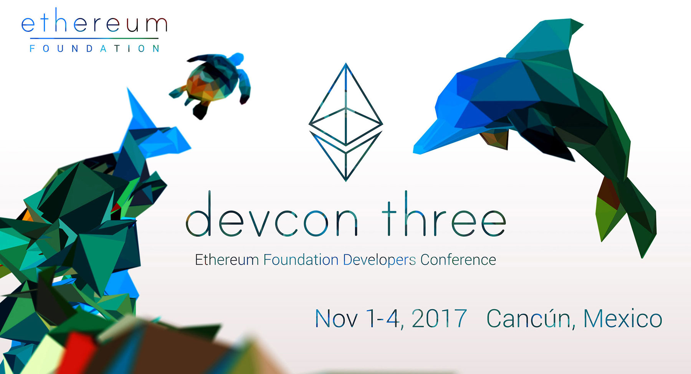

For those of you who have experienced Devcon in the past and are looking forward to this year’s event, it should be the best one to date! This year, the Ethereum Foundation(organizer) has dedicated convention center space that accommodates close to double the capacity as last year as well as a second hall to allow for more presentations and formats.

The Foundation is pleased to continue to provide the main developers conference in the Ethereum space for a community that stands out for its shared vision, drive, enthusiasm, and involvement in both community driven open source projects as well as rapidly growing ones taking shape in many other sectors including business, trade, industry, government, education and more.

It is our hope more Ethereum community members will be able to join in Devcon, especially aspiring developers and others who may contribute to the growing and valuable pipeline for innovation and implementation.

As a developers conference, Devcon3 programming is designed to help inform, educate, update and address interests of the Ethereum R&D community, including those who are in learning about the technology to become developers or wish to know more about Ethereum development and projects supported by the Foundation as well Ethereum innovation and development being undertaken in the greater ecosystem. While the program is technical by nature, all who wish to attend are welcome!

**Devcon3 I Date&Location**

**Date: November 1-4, 2017**

**Location: Cancún ICC (International Convention Center)**  
Boulevard Kukulcán KM. 9 1er Piso, Zona Hotelera, 77500 Cancún, Quintana Roo, Mexico. ([www.cancunicc.com/en/home/](http://cancunicc.com/en/home/) )

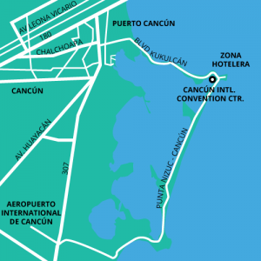

## Devcon3 | agenda & presentations

Ethereum Foundation is pleased to feature presentations on research and development it supports throughout the agenda, along with Ethereum community presentations from around the world. The agenda will be evolving with additions made until the program is finalized. As in past years, the exact times and duration of presentations listed will be adjusted to create conducive groupings and flow.

Please click the following link to check the detail agenda:

<https://ethereumfoundation.org/devcon3/agenda/>